Retele /23 – Popescu Dragos

/23 -> 2^(32-23) = 2^9 = 512 IP

N1:115 ->128/25

N2:107 -> 128/25

N3:35 -> 64/26

N4:35 -> 64/26

N5:11 -> 16/28

IP:154.183.116.0

NM: 255.255.254.0

NA: 154.183.116.0

BA: 154.183.117.255

N1: 154.183.116.0->154.183.116.127 R1: 154.183.116.1 S1: 154.183.116.2

N2: 154.183.116.128->154.183.116.255 R2: 154.183.116.129 S2WEB: 154.183.116.130

N3: 154.183.117.0->154.183.117.63 R3: 154.183.117.1 S3DNS: 154.183.117.2

N4: 154.183.117.64->154.183.117.127 R4: 154.183.117.65

N5: 154.183.117.128->154.183.117.143 R5: 154.183.117.129

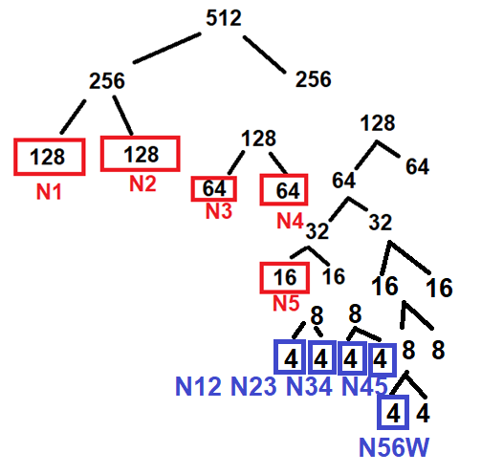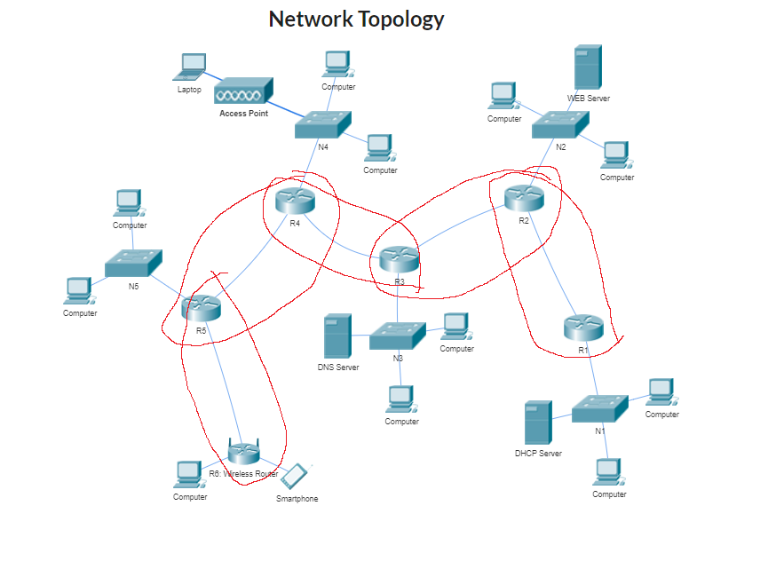

Other networks:

N12: 154.183.117.144->154.183.117.147 R1: 154.183.117.145 R2: 154.183.117.146

N23: 154.183.117.148->154.183.117.151 R2: 154.183.117.149 R3: 154.183.117.150

N34: 154.183.117.152->154.183.117.155 R3: 154.183.117.153 R4: 154.183.117.154

N45: 154.183.117.156->154.183.117.159 R4: 154.183.117.157 R5: 154.183.117.158

N56W: 154.183.117.160->154.183.117.163 R5: 154.183.117.161 R6: 154.183.117.162